VACVB  PO Box 3363  Warrenton, VA 20188  (P) (540) 904-4710  (F) (202) 962-3939  vacvb@colliegorg.com  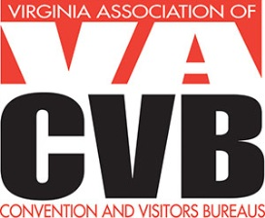 | dATE iNVOICE #  5/3/2013 2013 - 101  Invoice

Contact Information

Number of Submissions | DESCRIPTION | AMOUNT
 | 2013 Virgo Nominations –
 | One - $35
 | Two - $70
 | Three - $105
Thank you for your continued support of VACVB! TOTAL

Payment
Credit Card: VISA ____ MasterCard ____ AMEX ____

Name on Credit Card __________________________________________________
Credit Card # ________________________________________________________
Expiration Date ________________ 3 or 4 Digit CVV Code ___________________

Amount Authorized $_________________
Signature ___________________________________________________________
Date ______________________________

Checks should be made payable to VACVB (Federal ID #54-1788339) and sent to:
PO Box 3363, Warrenton, VA 20188

